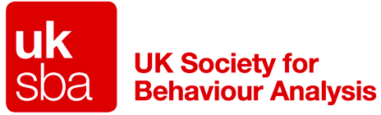
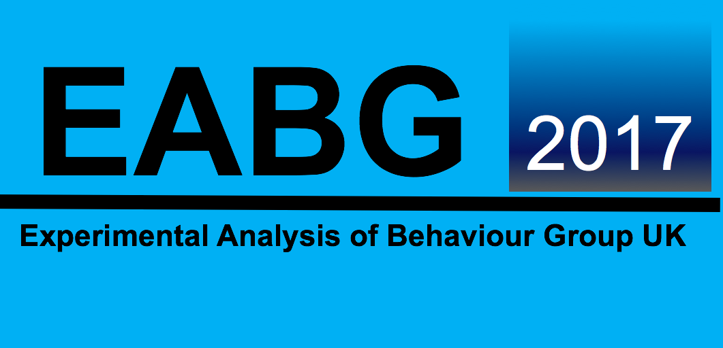

EABG 2017
London Conference

Call for Papers, Symposium, and Workshops

We are pleased to announce that the 2017 meeting of the EABG, the main UK meeting of behaviour analysis, will be held at University College London, April 10th-12th 2017. Symposium, papers, and posters are invited on experimental, applied, and conceptual aspects of behaviour analysis and learning. Titles and abstracts (150 words maximum) should be submitted before February 17th, 2017. Abstracts should be emailed to eabg17@bangor.ac.uk (web submission opens 12th January and closes 17th February).

We are pleased to announce the Key Note Speaker for EABG 2017 is
Professor Anthony Biglan
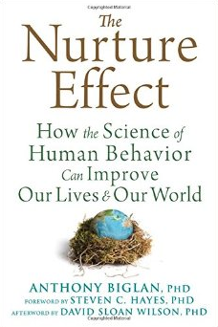

EABG Conference Organisers:
Dr J. Carl Hughes, BCBA-D  Dr Rebecca Sharp, BCBA-D  Dr Stacey Hunter, BCBA  Dr Amy Hulson-Jones  School of Psychology,  Bangor University, Wales, (UK). | Tel: +44 1248 383278  Fax: +44 1248 382599  E-mail: eabg17@bangor.ac.uk  EABG: http://eabg.bangor.ac.uk/  Twitter: @EABG17  Facebook: EABG2017

